S1739768

DAH Checkpoint 5: Temperature Sensors

***1. What is the interface between the DS18B20 temperature sensor and the Raspberry Pi? Explain how it works.***

(Note: both the sensors I had were DS18S20’s not DS18B20’s, as the serial numbers both started with 10-… which is the code for DS18S20)

The temperature sensor interfaced with the Raspberry Pi with a single wire connecting the DQ pin on the sensor to a GPIO pin on the Raspberry Pi. The DQ pin acts as a serial input and output line. A 1-wire master can communicate with one or more slave devices by using a device’s unique serial number in its commands to act as an address.

***2. What is the smallest change in temperature that a single sensor can report? Explain this with reference to the temperature data encoding described on the sensor datasheet.***

Had the DS18S20 temperature sensor had fixed 9-bit resolution (unlike the DS18S20) with the 8 least significant bits determining the value of the temperature and a 9th bit giving the sign (with 7 other duplicate sign bits) as shown in figure 1. The least significant bit corresponds to 2-1 = 0.5°C so this is the smallest temperature change a sensor could report.

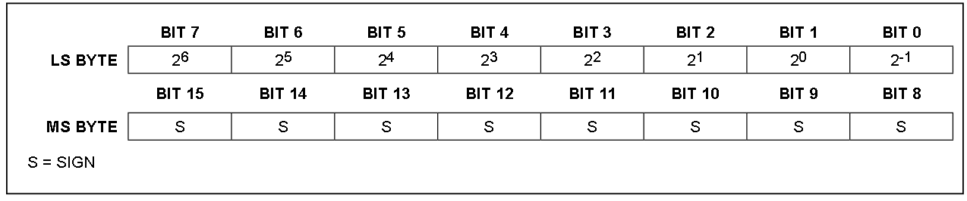Figure 1: ‘Temperature Register Format’ for DS18S20 temperature sensor from datasheet at https://datasheets.maximintegrated.com/en/ds/DS18S20.pdf

In practice, the sensor reported changes in temperature as small as ~0.062°C. Both the Linux commands and the webiopi method reported these 0.062°C changes which is smaller than expected for the 9-bit resolution measurement. Perhaps they were interpreting an underlying 12-bit resolution (as if it were the DS18B20 instead) which would have a least significant bit corresponding to 2-4 = 0.0625°C. However, there is only ‘±0.5°C accuracy from -10°C to +85°C’ according to the datasheet so these smaller changes are not necessarily accurate anyway.

***3. How do your two temperature sensors’ readings compare with each other? Is this what you would expect from the datasheet?***

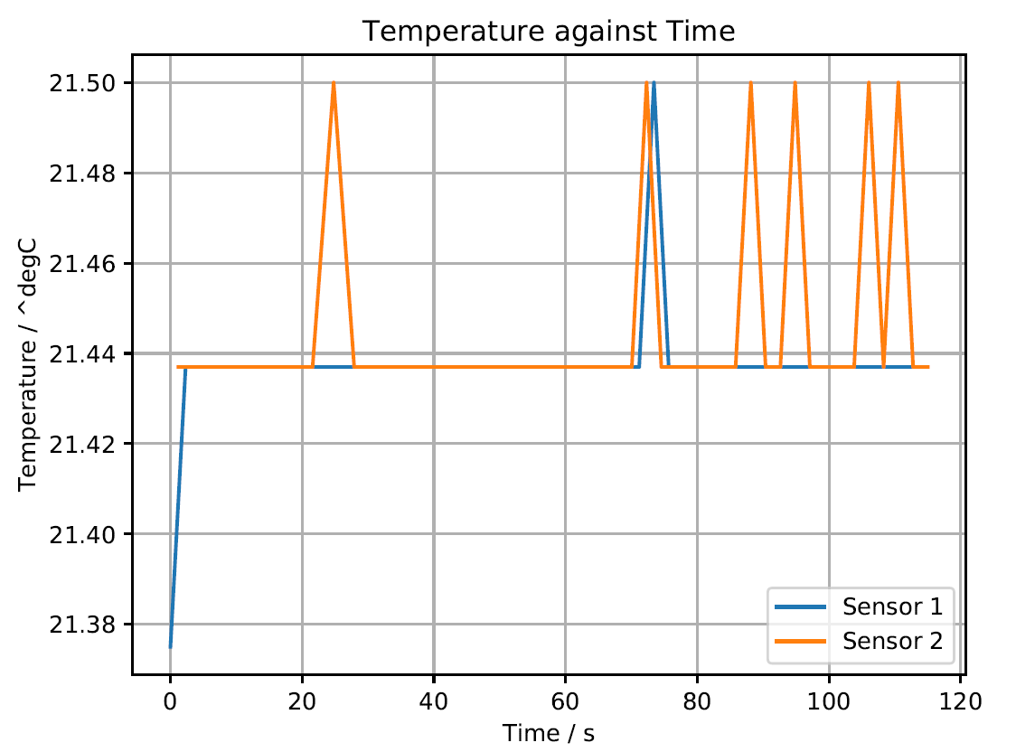

From the graph taken in the lab, the maximum difference in temperature between the two sensors could be ~0.12°C. The datasheet states they should each have ‘±0.5°C accuracy from -10°C to +85°C’ so the temperature differences measured in the lab are acceptable as the difference is less than 1°C.